|  |  |
| --- | --- |
|  | **DEPARTMENT OF COMPUTER SYSTEMS ENGINEERING**  **MEHRAN UNIVERSITY OF ENGINEERING & TECHNOLOGY, JAMSHORO**  **Database Management Systems (4th Semester) 18CS**  **Lab Experiment 2** |

|  |  |  |  |
| --- | --- | --- | --- |
| **Roll No:** |  | **Date of Conduct:** |  |
| **Submission Date:** |  | **Grade Obtained:** |  |

|  |  |  |  |
| --- | --- | --- | --- |
| **Problem Recognition (0.3)** | **Completeness & accuracy (0.4)** | **Timeliness (0.3)** | **Score (1.0)** |
|  |  |  |  |

**Objective: Creating Form and generating Reports on database in MS Access**.

**Tools:** MicroSoft Access

**Introduction:**

**Create a form from an existing table or query in Access:**

To create a form from a table or query in your database, in the Navigation Pane, click the table or query that contains the data for your form, and on the Create tab, click Form.

Access creates a form and displays it in Layout view. You can make design changes like adjusting the size of the text boxes to fit the data, if necessary. For more information, see the article on using the form tool.

**Create a blank form in Access**

1. To create a form with no controls or preformatted elements: On the Create tab, click Blank Form. Access opens a blank form in Layout view, and displays the Field List pane.
2. In the Field List pane, click the plus sign (+) next to the table or tables that contain the fields that you want to see on the form.
3. To add a field to the form, double-click it or drag it onto the form. To add several fields at once, hold down CTRL and click several fields, and then drag them onto the form at the same time.

**Note:** The order of the tables in the Field List pane can change, depending on which part of the form is currently selected. If you are not able to add a field to the form, try selecting a different part of the form and then try adding the field again.

1. Use the tools in the Controls group on the Form Layout Tools tab to add a logo, title, page numbers, or the date and time to the form.
2. If you want to add a wider variety of controls to the form, click Design and use the tools in the Controls group.

## Creating Reports:

Reports organize and summarize data for viewing online or for printing. A detail report displays all of the selected records. You can include summary data such as totals, counts, and percentages in a detail report. A summary report does not list the selected records but instead summarizes the data and presents totals, counts, percentages, or other summary data only. Access has several report generation tools that you can use to create both detail and summary reports quickly.

**To use the Report button:**

1. Open the Navigation pane.
2. Click the table or query on which you want to base your report.
3. Activate the Create tab.
4. Click the Report button in the Reports group. Access creates your report and displays your report in Layout view. You can modify the report.

#### **To create a report by using the Report Wizard:**

##### **Open the Report Wizard**

1. Activate the Create tab.
2. Click Report Wizard in the Reports group. The Report Wizard appears.

**Lab Task**

1. 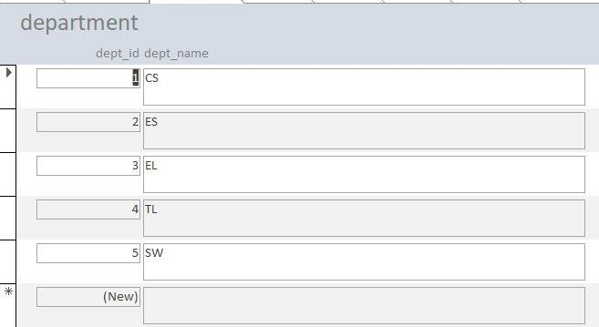**Create forms for each table created in lab#1.**

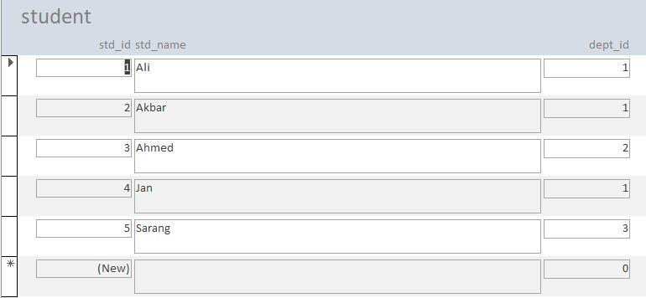

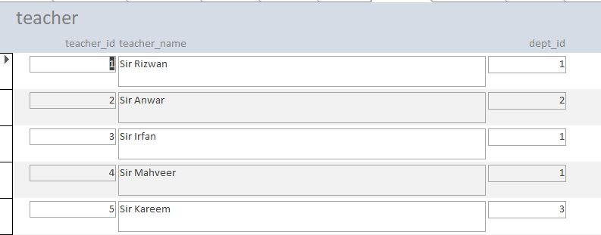

1. 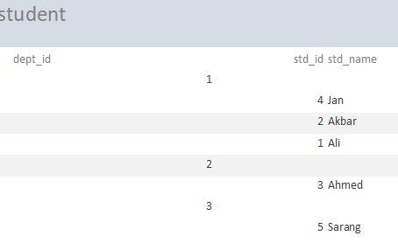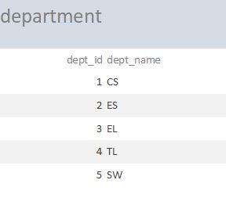**Generate reports for each table created in lab#1.**

